**Practical – 4**

**Aim: Write a PHP program for storing and retrieving user information from MySQL table.**

a. Design a HTML registration and login page which takes name, password, email and mobile number from user.

b. Store this data in MySQL database.

c. On next page display all user in HTML table using PHP.

d. Update/Delete details of user.

**CODE (Form):**

Form.html

<!DOCTYPE html>

<html lang="en">

<head>

<meta charset="UTF-8">

<meta http-equiv="X-UA-Compatible" content="IE=edge">

<meta name="viewport" content="width=device-width, initial-scale=1.0">

<title>Registration</title>

<style>

body {

background-color: darkslategray;

}

h1 {

font-size: 900;

color: white;

font-family: Verdana, Geneva, Tahoma, sans-serif;

background-color: indianred;

color: black;

padding: 5px 5px;

}

form {

display: inline-block;

background-color: indianred;

border-radius: 5px;

padding: 50px 50px;

border-radius: 10px;

}

#form {

display: block;

text-align: center;

}

label {

font-size: larger;

font-weight: 700;

color: black;

font-family: 'Product Sans', 'Manrope', Calibri, 'Trebuchet MS', sans-serif

}

#submit {

font-size: medium;

background-color: white;

color: indianred;

font-weight: bold;

margin-top: 20px;

margin-left: 5px;

height: 30px;

border: 0;

border-radius: 5px;

}

#submit:hover {

background-color: rgb(180, 65, 65);

color: white;

}

</style>

</head>

<body>

<h1 style="text-align: center;">Register Now!</h1>

<div id="form">

<form method="POST" action="insert.php">

<div class="form">

<label for="name">Name </label>

<input type="text" id="name" name="name" required style="margin-left: 100px;">

</div>

<div class="form">

<label for="email">Email </label>

<input type="email" id="email" name="email" required style="margin-left: 100px;">

</div>

<div class="form">

<label for="mn">Mobile Number </label>

<input type="tel" id="mn" name="mn" required style="margin-left: 15px;">

</div>

<div class="form">

<label for="pass">Password </label>

<input type="password" id="pass" name="pass" required style="margin-left: 65px;">

</div>

<div style="display: block;">

<input type="submit" name="SUBMIT" id="submit">

</div>

</form>

</div>

</body>

</html>

**OUTPUT:**

**CODE (Connecting Database):**

connectsql.php

<?php

$servername = "localhost";

$username = "root";

$password = "";

$db = "P4";

$conn = mysqli_connect($servername,$username,$password,$db);

if(!$conn)

{

echo "Connection not established : ". mysqli_connect_error();

}

?>

**CODE (Inserting Data):**

insert.php

<?php

include "connectsql.php";

if($_SERVER['REQUEST_METHOD']=='POST')

{

$name = $_POST['name'];

$email = $_POST['email'];

$mn = $_POST['mn'];

$sql = "INSERT INTO `p4`(`Name`, `Email`, `Mobile`) VALUES ('$name','$email','$mn')";

$result = mysqli_query($conn,$sql);

if($result)

{

mysqli_close($conn);

header("location: show.php");

}

else

{

echo "Error inserting : ". mysqli_error($conn);

}

}

?>

**CODE (Fetching Data - Show):**

show.php

<style>

table,th,td,tr{

border : 2px solid black;

}

</style>

<?php

include "connectsql.php";

$sql = "SELECT * FROM `p4`";

$result = mysqli_query($conn,$sql);

if($result)

{

$num = mysqli_num_rows($result);

if($num>0)

{

echo "<table><tr><th>Sr.No</th><th>Name</th><th>Email</th><th>Mobile</th><th>Edit</th><th>Delete</th></tr>";

while($row = mysqli_fetch_assoc($result))

{

echo "<tr><td>".$row["Sr.no"]."</td><td>".$row["Name"]."</td><td>".$row["Email"]."</td><td>".$row["Mobile"]."</td>";

echo '<td><b><font color="#663300"><a href="edit.php?id=' . $row['Sr.no'] . '">Edit</a></font></b></td>';

echo '<td><b><font color="#663300"><a href="delete.php?id=' . $row['Sr.no'] . '">Delete</a></font></b></td>';

echo "</tr>";

}

echo "</table>";

}

else

{

echo "No records found!!";

}

}

?>

**CODE (Deleting Data):**

delete.php

<?php

include "connectsql.php";

$id = $_GET['id'];

$sql = "DELETE FROM `p4` WHERE `Sr.no` = $id";

$result = mysqli_query($conn,$sql);

if($result)

{

mysqli_close($conn);

header("location:show.php");

}

else

{

echo "Error deleting...". mysqli_error($conn);

}

?>

**CODE (Updating Data):**

edit.php

<?php

include "connectsql.php";

$id = $_GET['id'];

$fsql = "SELECT * FROM `p4` where `Sr.no` = $id";

$fresult = mysqli_query($conn,$fsql);

$data = mysqli_fetch_assoc($fresult);

if(isset($_POST['update']))

{

$name = $_POST['name'];

$email = $_POST['email'];

$mn = $_POST['mn'];

$sql = "UPDATE `p4` SET `Name`='$name',`Email`='$email',`Mobile`='$mn' WHERE `Sr.no` = $id";

$result = mysqli_query($conn,$sql);

if($result)

{

mysqli_close($conn);

header("location:show.php");

}

else

{

echo "Error Updating...". mysqli_error($conn);

}

}

?>

<!DOCTYPE html>

<html lang="en">

<head>

<meta charset="UTF-8">

<meta http-equiv="X-UA-Compatible" content="IE=edge">

<meta name="viewport" content="width=device-width, initial-scale=1.0">

<title>Update Data</title>

</head>

<body>

<h2 style="text-align: center;">Update your credentials!!</h2>

<div class="container">

<form method="POST">

<table>

<tr>

<td>Name : </td>

<td><input type="text" value="<?php echo $data['Name']; ?>" name="name" required></td>

</tr>

<tr>

<td>Email : </td>

<td><input type="email" value="<?php echo $data['Email']; ?>" name="email" required></td>

</tr>

<tr>

<td>Mobile : </td>

<td><input type="text" value="<?php echo $data['Mobile']; ?>" name="mn" required></td>

</tr>

</table>

<input type="submit" value="UPDATE" name="update">

</form>

</div>

</body>

</html>

**OUTPUT (Fetching Data):**

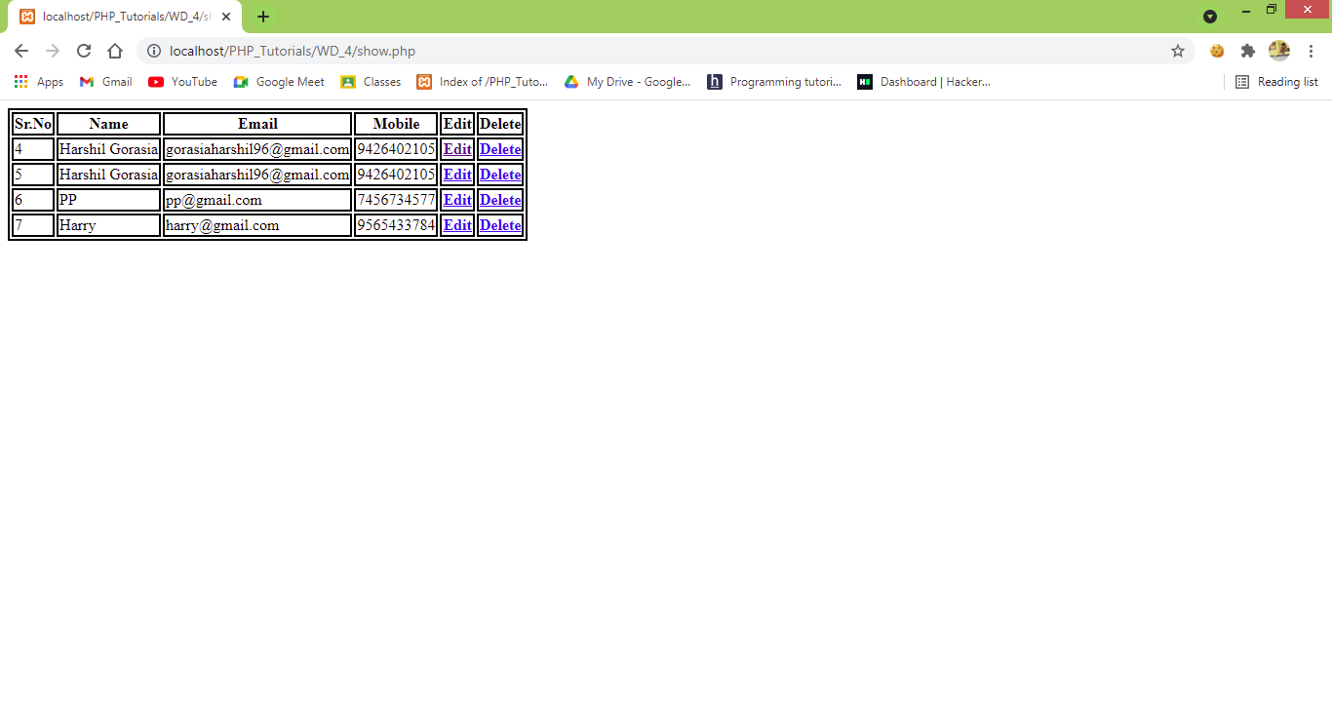

**OUTPUT (Deleting Data):**

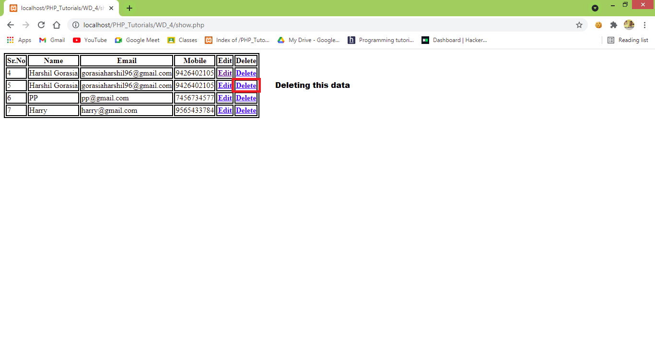

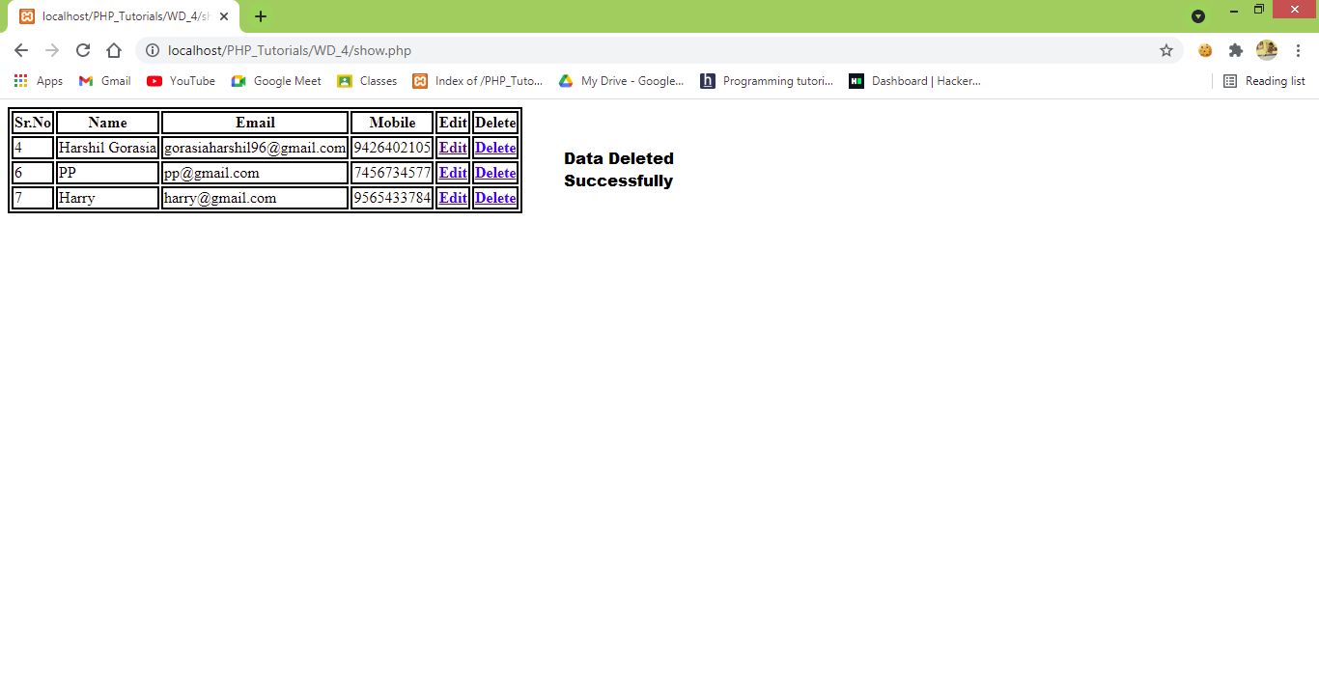

OUTPUT (Updating Data):

